Қызылсая орта мектебі

АШЫҚ САБАҚ
Тақырыбы: «My father's hobby»

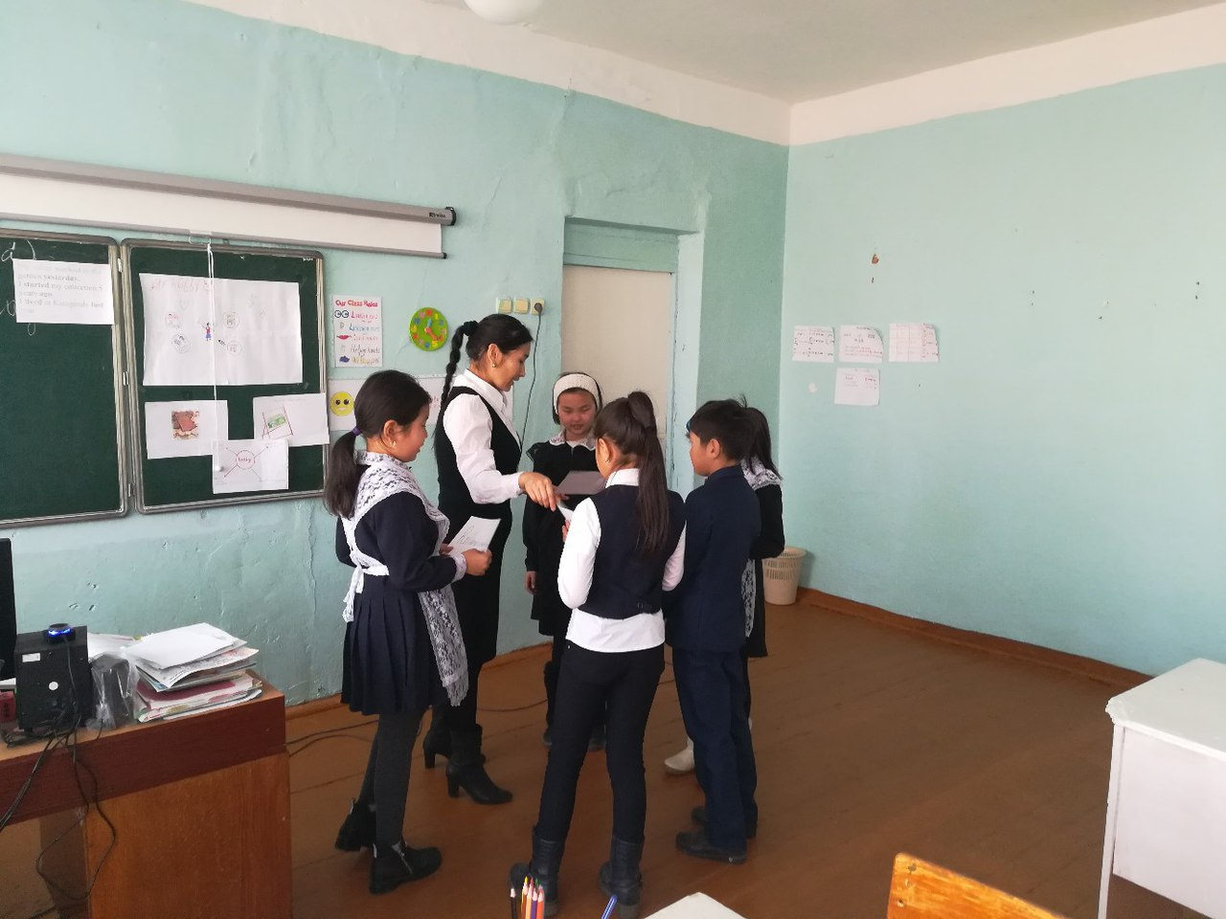

Өткізген: Каюпова Д.Д.

2016-2017 оқу жылы

Date:
Grade: 4
The theme of the lesson: «My father's hobby»
Literature: English 4 grade
Aims of the lesson: At the end of the lesson the students will be able to
1. Identify regular verbs
2. Discriminate long a sound
3.Construct sentences with Past Simple
Results of teaching: Students will work with groups
Students will know about hobbies and about Alibek's fathers hobby
Students will know about Past Simple and regular verbs
Main ideas: Learning English new words and English grammar
Тasks: 1st task-Dividing into three groups
2nd task-English sounds. Listening audio disk
3rd task- Exercises 2 and 3, page 24.
4th task- Look at the pictures and answer the questions. Listen and read
5th task-Answer the questions
6th task-Grammar Past Simple
7th task-exercise 7, page -7
1st task.
( 5 minutes) Dividing into three groups
1st group´s name is-origami
2nd group is- hobby
3rd group is- collection
Resources: Stickers
2nd task.
( 2 minutes) English sounds. Listening audio disk
Listen and repeat long a a, ay, ai
Rain, day, plane, play, train, Jane
Resources: Audio disk. Computer
3rd task
( 10 minutes) Exercises 2 and 3, page 24.
2.Read
This is Jane.She likes rain.Today is her favourite day.It is a rainy day.She likes playing in rain.These are a train and a plane.Jane likes travelling by train and by plane
3.Read and choose the words with a long a sound.
May, paint, cat, stay, say, apple, ant, play, rain, hat, table, lady, candle, man, day.
Resources: English 4 grade
4th task
( 10 minutes) Look at the pictures and answer the questions.Listen and read
5th task
(3 minutes) Answer the questions
1. What is Alibek showing to his father?
2. What is his father´s hobby?
3. Is Alibek´s stamp old or new?
4. How many stamps are there in Alibek´s fathers collection?
6th task
(3 minutes) Grammar Past Simple
Past Simple. Positive form
We use Past Simple to speak about actions in the past
We use –ed, -d to make Past Simple
Start-started
Work-worked
Live-lived
My father worked in the garden yesterday
I started my collection 5 years ago
I lived in Karagandy last year
7th task
(2 minutes) exercise 7, page -7
Liked
Danced
Helped
Watched
Talked
Presented
Assessment
(5 minutes)
Home task
(5 minutes) Exercises 1,2, 3, pages 14-15
Reflection
Evaluation of the teacher

